**Ideation Phase**

**Brainstorm & Idea Prioritization Template**

|  |  |
| --- | --- |
| Date | 27 June 2025 |
| Team ID | LTVIP2025TMID34246 |
| Project Name | Transfer Learning-Based Classification of Poultry Diseases for Enhanced Health Management. |
| Maximum Marks | 4 Marks |

**Brainstorm & Idea Prioritization Template:**

Poultry farmers face significant challenges in detecting diseases at an early stage, often resulting in high bird mortality and economic losses. Traditional diagnostic methods are costly, time-consuming, and typically unavailable in rural areas. To address this gap, our team leveraged AI-powered computer vision to automate and accelerate poultry disease detection.

Reference: <https://www.mural.co/templates/brainstorm-and-idea-prioritization>

**Step-1: Team Gathering, Collaboration and Select the Problem Statement**

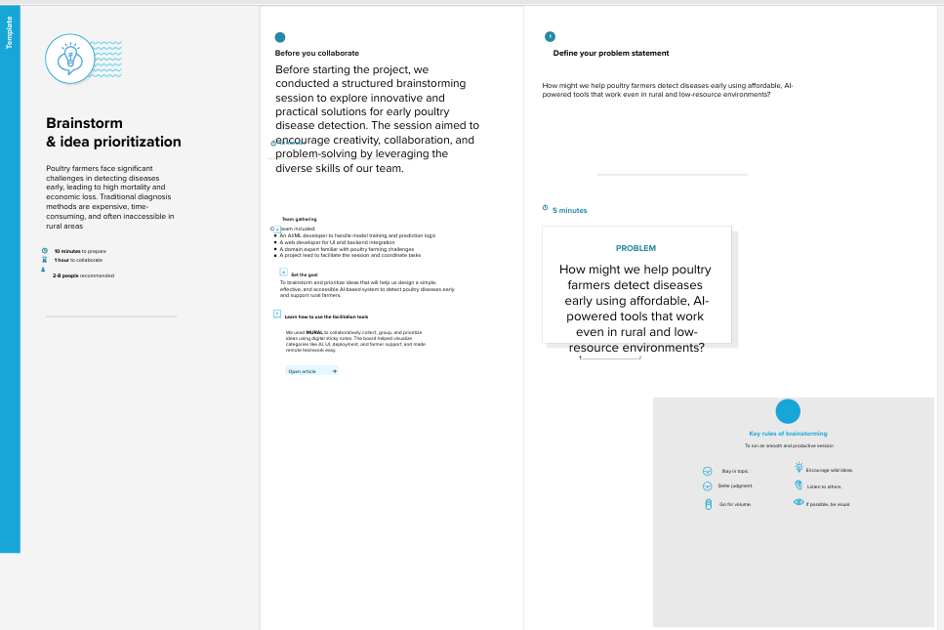

**Step-2: Brainstorm, Idea Listing and Grouping**

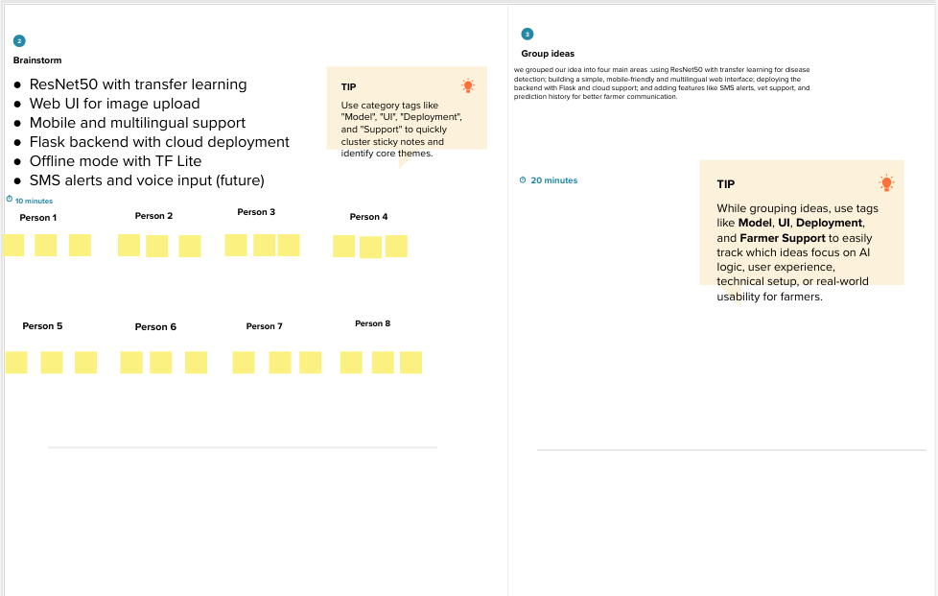

**Step-3: Idea Prioritization**

